County Letters
County letters will be received from county for Exemption details of the property or owners. This letter will be received by OCA and forwarded to the property owner from the OCA by the USmail.
County letters are scanned by Houston team by using paperiwise tool in INbatches.
County letter has Printed date and OCA seal date. If any document scanned without seal should be routed to scanning defect queue without do indexing.

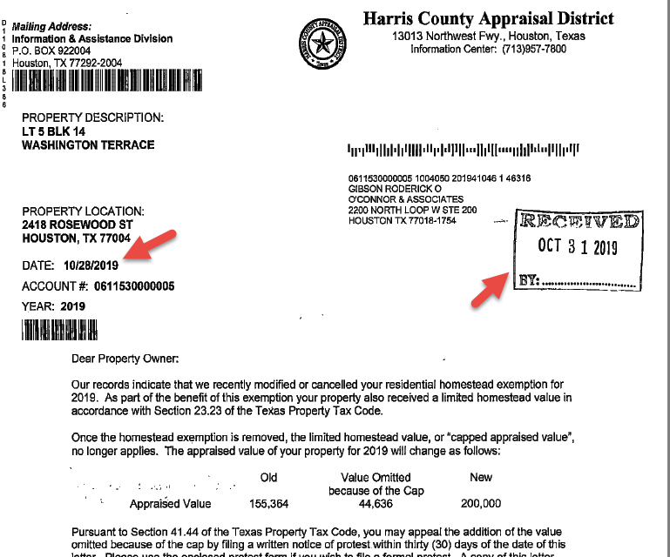

Also, we will receive the letter from property Owners through Right fax email box via PF and SC Batches. This letter should not forward to the property owner.
Indexing agent should index the document with the respective account mentioned in the document and route the document to New IDE Queue.

Process flow:-
DE agent will copy the account and search it as account search in spartaxx main screen.
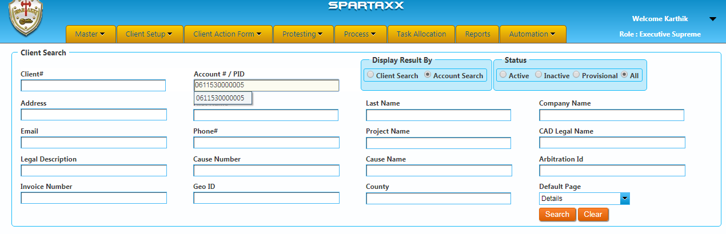
DE agent should match the owner name in county letter, CAD & spartaxx.
Property Owner confirmation: -
Spartaxx:-
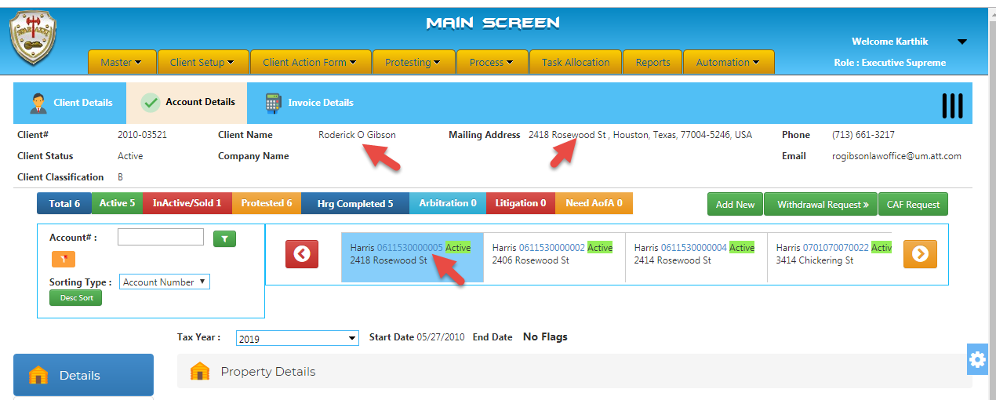
CAD Sheet”-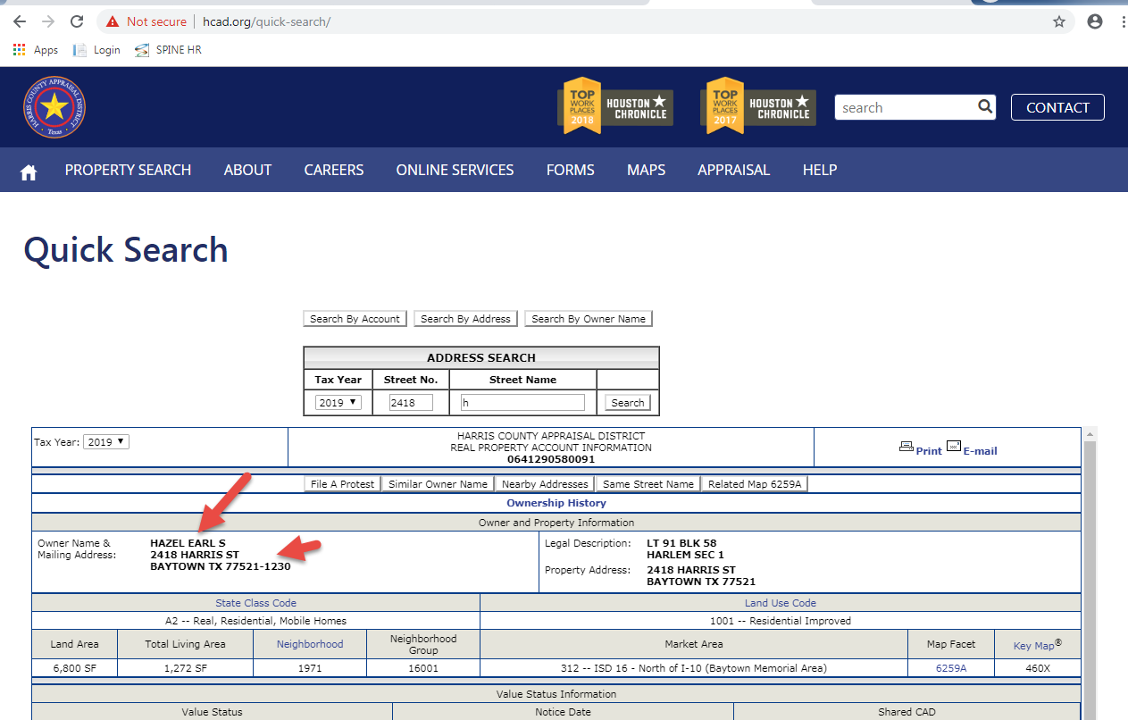
County Letter:-
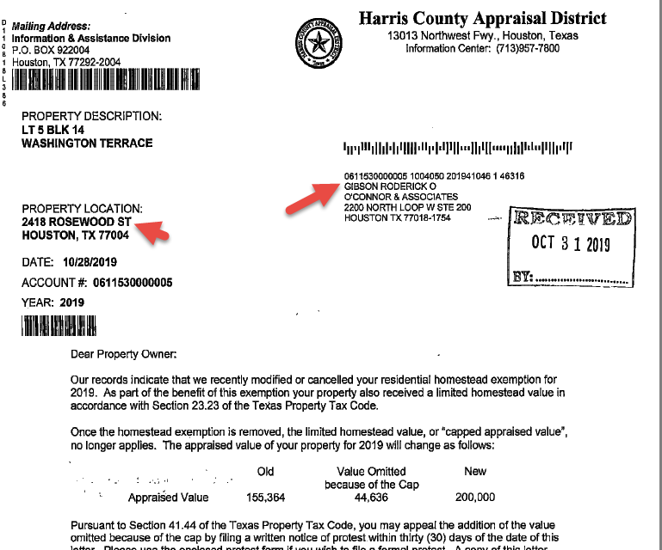
If it is matches should pull the active OCA cover letter from report menu in spartaxx.
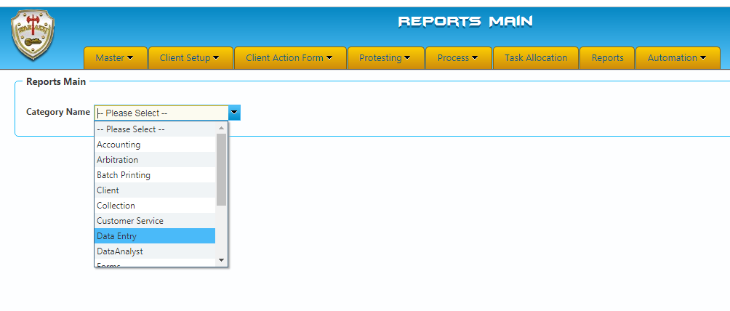

Selecting Report Letter:-
- Active
- Inactive
- DND
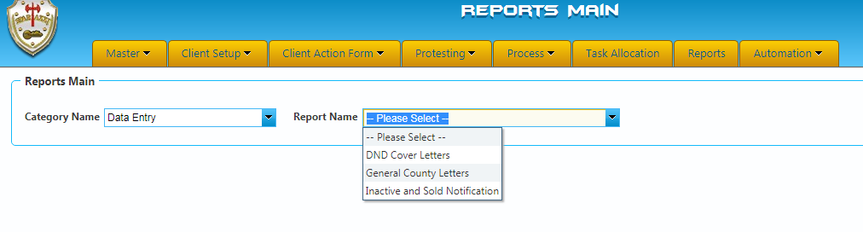
Selecting CAD:-
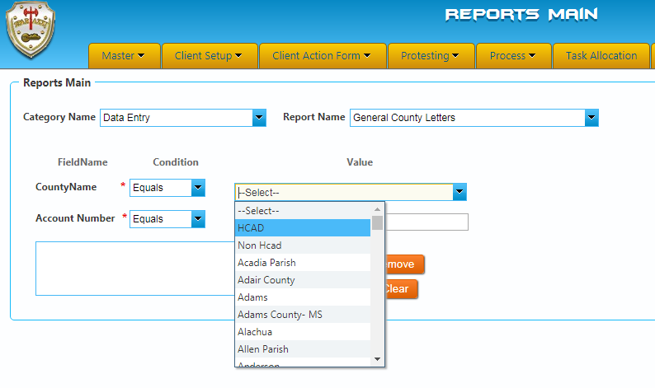
Account number Entry:-
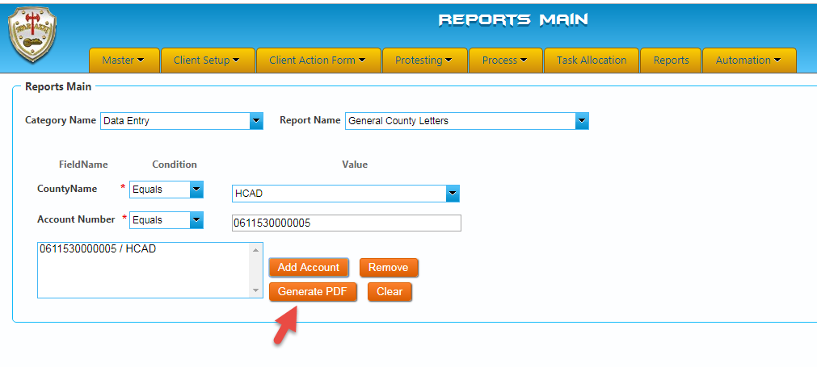
Cover Letter:-
Active cover letter will be shown in the below format.
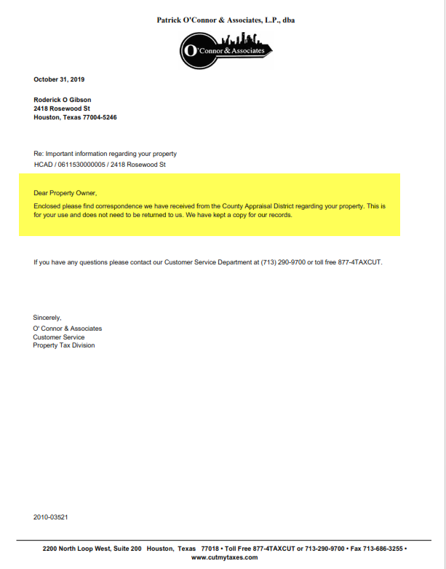
Inactive & Sold:-
For inactive & Sold, we have an option that we should pull the cover letter in Inactive & Sold Notification.
DND:-
For DND, we have an option that we should pull the cover letter in DND Cover letter option.

After OCA cover letter generated the log will be captured in call log status as shown in the below screen shot.
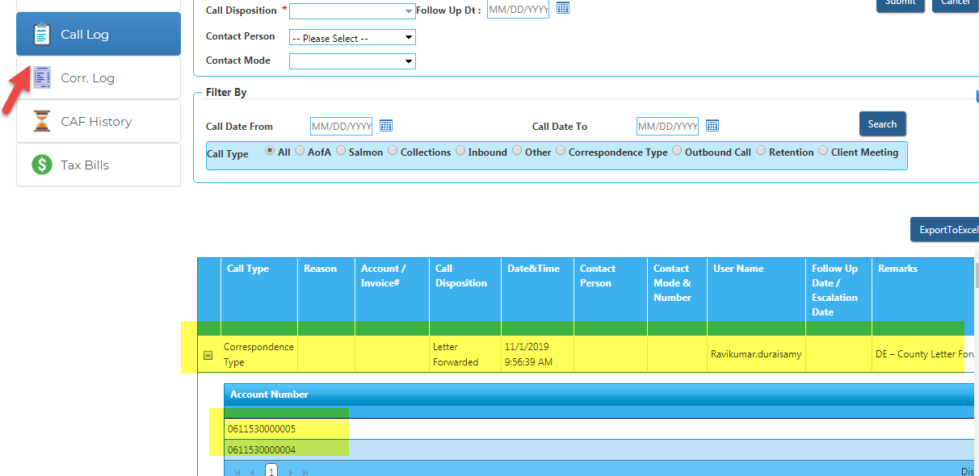

Meanwhile, Agent should download the county letter from paperwise and paste it into local folder.
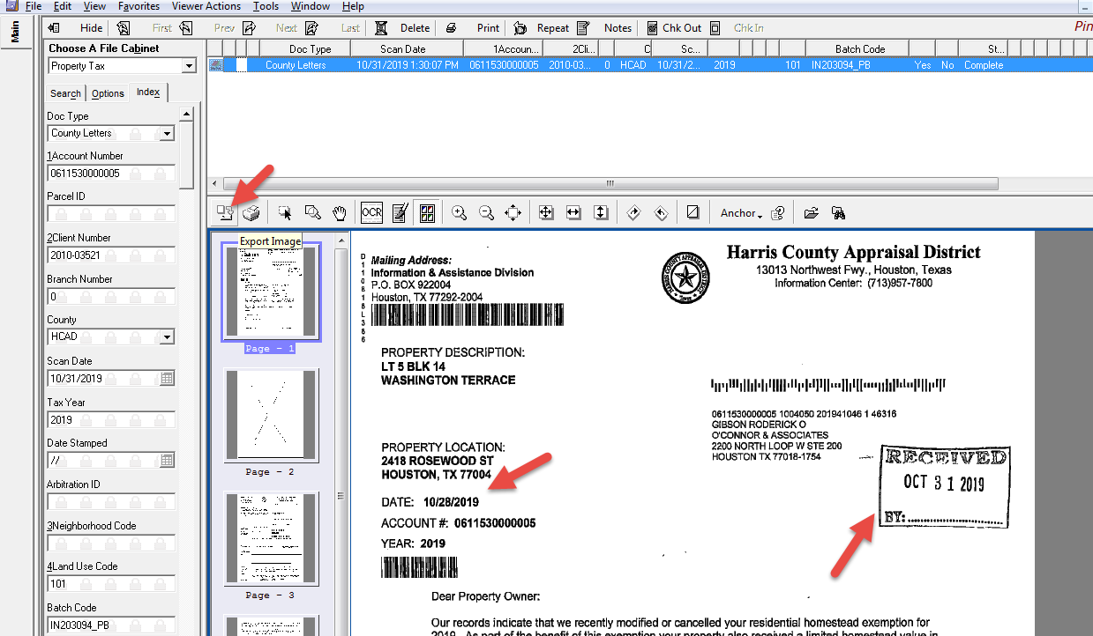
Agent will combine the cover letter, received county letter and paste it into DE NEOpath folder.

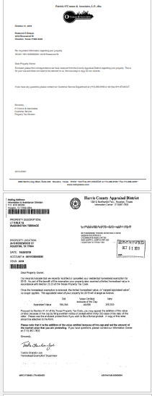
NEO Path:-
Merged document should save it the mentioned format and pasted under the below path.
CL_0611530000005_2010-03521_Hcad
\\spartaxxpub\SpartaxxNeoPost\DE Letters
Once, pasted above path user should complete the document in paperwise.

Temporarily, we have to track the received county letters details in the spreadsheet and share to Houston agent at the EOD on daily basis.
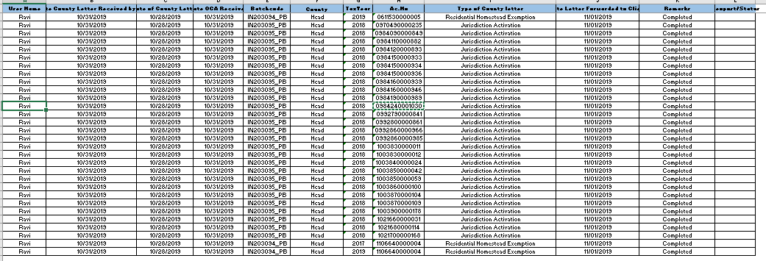

Status Report Email to Houston Team:-
At EOD we should send the status to Houston Team for let them know the county letter status on Daily basis with the below format.
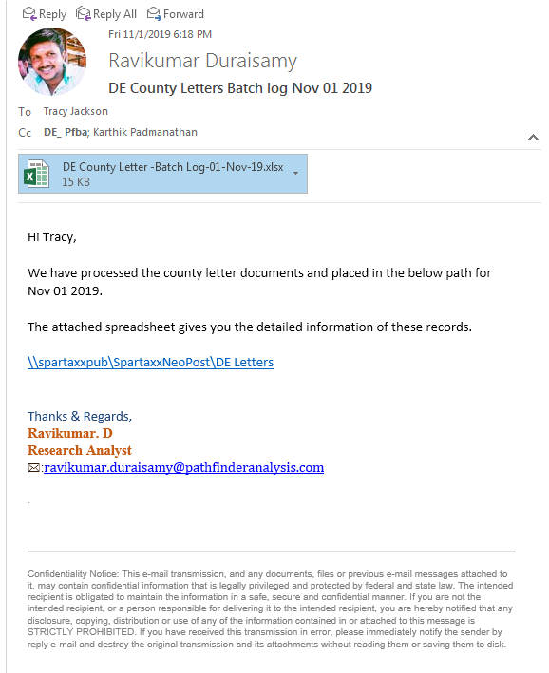
Tax Statement
As like county letter we will receive the tax statement from county, and we will do research as like county letter, if it is active will combine cover letter and paste it into NEO path folder.

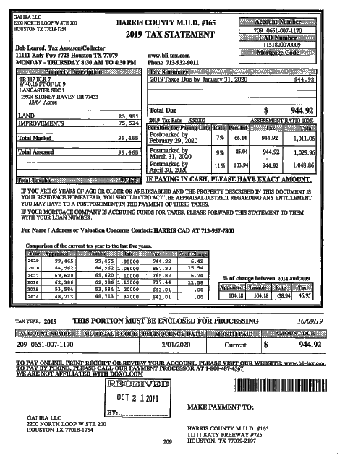
Also, we will receive the letter from property Owners through Right fax email box through PF and SC Batches. This letter should not be forwarded to the property owner.
Indexing agent should index the document with the respective account mentioned in the document and route the document to New IDE Queue.
NEO Path:-
Merged document should save it the mentioned format and pasted under the below path.
Tax Statement_0611530000005_2010-03521_Hcad
\\spartaxxpub\SpartaxxNeoPost\DE Letters
Once, pasted above path user should complete the document in paperwise.

